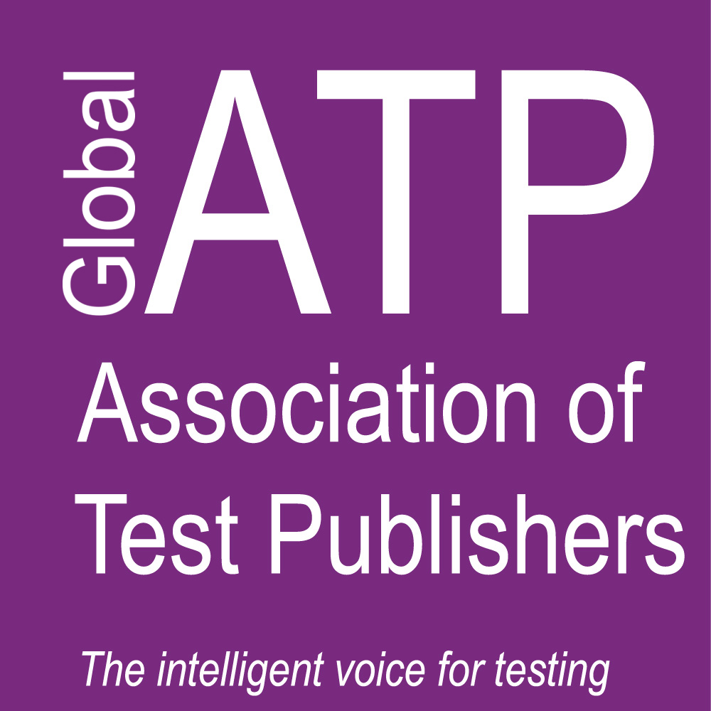
Call for Presentations
ATP Public Sector Special Interest Group (SIG)

Using 21st Century Tools to Transform the Public Sector

The Association of Test Publishers invites contributions to its seventh annual Public Sector SIG conference scheduled for September 9-10 2019 in Vienna, Austria.

Technology, gamification, privacy and security issues, social and political shifts are all changing the landscape of how we actively recruit, assess, educate, and promote public sector employees. The Internet, together with global shift, has significantly changed the way individuals work, engage with colleagues, and develop their careers – and these changes are taking place in all workplace settings. That is why ATP has dedicated part of its mission to creating communities, such as the Public Sector SIG, that transcend national and international borders – so that networks can be built, and the very best innovations and best practices can be shared among like-minded professionals.

Therefore, this year’s conference, hosted by the Organization for Security and Co-operation in Europe (OSCE), will bring together a community of international practitioners, academics and public sector professionals for a day and a half of programming.

This year’s Conference Committee invites presentations related to issues and concerns, innovations and advances, that may consider but are not limited to:

Technology-driven candidate selection;
Diversity analysis and reporting;
Personalized learning; Performance Testing;
Soft-skills assessment;
Candidate experience software;
Artificial Intelligence in assessments;
Game-based assessment

Best Practices in:
Computer adaptive testing;
Accessibility and diversity;
Proctoring;
Workforce Credentialing;
Ethics;
Candidate Relationship Management

Submission Guidelines

We seek the following kinds of presentation submissions:

· Educational or academic in nature [i.e. not sales of products or services]
· Presentations that include case studies.
· Engaging workshop submissions*

[*All presentations must fit into a 45 minute time slot including 15 minutes for questions. Workshops will be considered for a 1 hour time slot, including 15 minutes for questions.]

The review process will be blind, but presenter names, affiliations and contact information should be listed in the submission.

Each submission will be reviewed by at least two Programme Committee members. The acceptance decisions will take into account relevance to the theme, practical application and programme scope. Please note that presenting at the conference will not result in an advantage for an organization in a tendering process.

Please submit proposals at this link:

https://atpu.memberclicks.net/index.php?option=com_mc&view=mc&mcid=form_251613

Inquiries can be sent to: lauren@testpublishers.org

Important Dates
· Submission deadline: Friday, April 26 2019
· Acceptance notification: Friday, May 24 2019

Public Sector SIG 2019 Conference Chair: Gustavo Araujo, Chief, Recruitment Unit, OSCE

