**Sponsorship Levels and Benefits:**

**ACADEMIC PARTNER = $5,000 USD / 350955 INR**

• Your company will be entitled to participate in one educational session in addition to benefits below.

**GOLD SPONSOR = $3,000 USD / 210573 INR**

• This level of partnership will enable your company to have a stand/booth in addition to all benefits below.

**SILVER SPONSOR = $1,500 USD / 105286 INR**

• A one -page advertisement can be placed in the delegate folder.

• Your organization will be listed on all signage.

• You will receive the pre and post-conference attendee list.

__________________________________________________________________________________________

_________________________________________________would like to sponsor I-ATP 2019 at the: ____Academic Partner level ____Gold Level ____Silver Level

Name:_________________________________________ Email:_________________________________________

Company:______________________________________ Email to send invoice:____________________________

Questions? Contact Lauren Scheib at Lauren@testpublishers.org No cancellations after Oct. 30 2019

Friday,

20th December 2019

India Habitat Centre

New Delhi

**Agenda**

• Panel discussions and debates from universities and workplace professionals

• Technology trends in higher education and professional certifications

• Relevance of certification for professional

• Networking lunch with thought leaders

**Who's attending?**

• Decision makers and faculty from academia / universities

• Educational thought leaders

• Corporate CXOs and HR fraternity

• Association bodies

• Friends from media

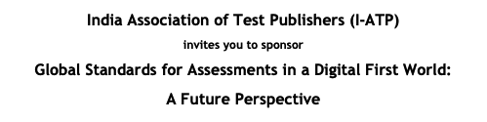

Sponsorship

Opportunities

