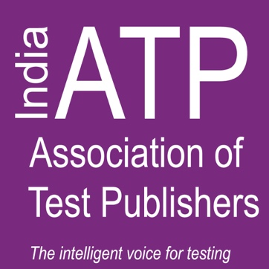

Agenda

* Panel discussions and debates from universities and workplace professionals
* Technology trends in higher education and professional certifications
* Relevance of certification for professional
* Networking lunch with thought leaders

Who's attending?

* Decision makers and faculty from academia / universities
* Educational thought leaders
* Corporate CXOs and HR fraternity
* Association bodies
* Friends from media

Sponsorship Levels and Benefits:

ACADEMIC PARTNER = $5,000 USD (359925 INR)

• Your company will be entitled to participate in one educational session in addition to benefits below.

GOLD SPONSOR = $3,000 USD (215955 INR)

• This level of partnership will enable your company to have a stand/booth in addition to all benefits below.

SILVER SPONSOR = $1,500 USD (107977 INR)

• A one -page advertisement can be placed in the delegate folder.

• Your organization will be listed on all signage.

• You will receive the pre and post-conference attendee list.

__________________________________________________________________________________________

I would like to sponsor I-ATP 2018 at the: ____Academic Partner level ____Gold Level ____Silver Level

Name:_________________________________________ Email:_________________________________________

Company:______________________________________ Email to send invoice:____________________________

Questions? Contact Lauren Scheib at [Lauren@testpublishers.org](mailto:Lauren@testpublishers.org) No cancellations after Oct. 30 2018

**India Association of Test Publishers (I-ATP)**

**invites you to sponsor**

**Revamping Exam Standards in India:**

***Improving Evaluation and Assessments for Higher Education and Professionals***

Friday, 30th November, 2018

Silver Oak Room, India Habitat Centre

Lodhi Road, New Delhi -110003

Sponsorship Opportunities