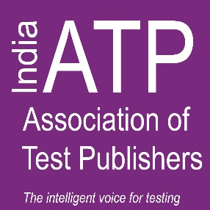
Global Standards for Assessments in a Digital First World: A Future Perspective

PROGRAM AGENDA – INDIA ATP 2019

Friday, 20 December 2019
India Habitat Centre, New Delhi
Silver Oak Room

08:30 AM – 09:30 AM Registration (networking tea and coffee)

9:30 AM – 10:00 AM Opening remarks and lighting of the lamp

          - Welcome note by William G. Harris, Ph.D., CEO, ATP
          - Welcome note by Divyalok Sharma, Chair IATP & Senior Director, Pearson VUE
          - Address by Chief Guest - Shri. Manish Sisodia, Hon’ble Deputy Chief Minister, New Delhi

10:00 AM – 10:30 AM Keynote Speaker – Dr. Sandhya Chintala, Vice President, Sector Skills Council, NASSCOM

10:30 AM – 11:15 AM Guest Speaker: “Eliminating cultural, geographic, and socioeconomic diversity influences in reading assessment” - Paul Edelblut, Vice President, Vantage Labs

11:15 AM – 11:45 AM Breakout Session + Tea – Visit sponsor booths and speak to experts

11:45 AM – 12:30 PM Guest Speaker: Dr. Jonathan Schmidgall, Research Scientist, Educational Testing Service (ETS)

12:30 PM – 1:15 PM Guest Speaker: Rajiv Razdan, VP (Digital Sales), Eupheus Learning
1:15 PM – 02:15 PM Networking Lunch

02:15 PM – 03:00 PM Guest Speaker: Jaydeep Singh, Founder and CEO, Empass Learning

03:00 PM – 03:30 PM Tea Break + Breakout session

03:30 PM – 04:15 PM Guest Speaker: Somdev Chaudhuri, Consultant Manipal Global Education Services

04:15 PM – 05:00 PM Motivational Speaker: Harish Anchan, Director, Apricate Training P. Ltd.
05:00 PM - 05:05 PM Closing remarks by the Chair/Vote of Thanks

5:05 PM onwards Distribution of ATP Participation Certificates | Networking

THANK YOU SPONSORS!

FOUNDING MEMBER SPONSORS

SILVER SPONSORS

© 2019 All Rights Reserved

